# <오전>

(<https://github.com/masungil70/docker-kubernetes/blob/main/chapter4/4.3%20Nginx%EB%A5%BC%20%EB%A6%AC%EB%B2%84%EC%8A%A4%20%ED%94%84%EB%A1%9D%EC%8B%9C(Reverse%20Proxy).txt>)

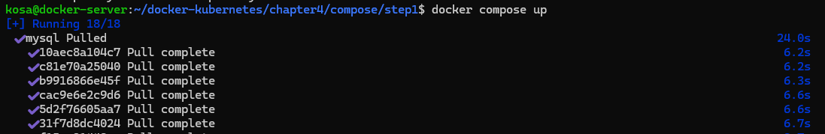

# <오후>